Contraception methods
Long-acting reversible contraception (LARC) methods

You do not need to remember to use these each time you have sex
Method | Intrauterine device (IUD) – copper IUD  Cu-IUD 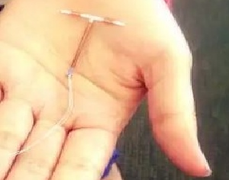 | Intrauterine device (IUD) – hormonal IUD  Mirena™ 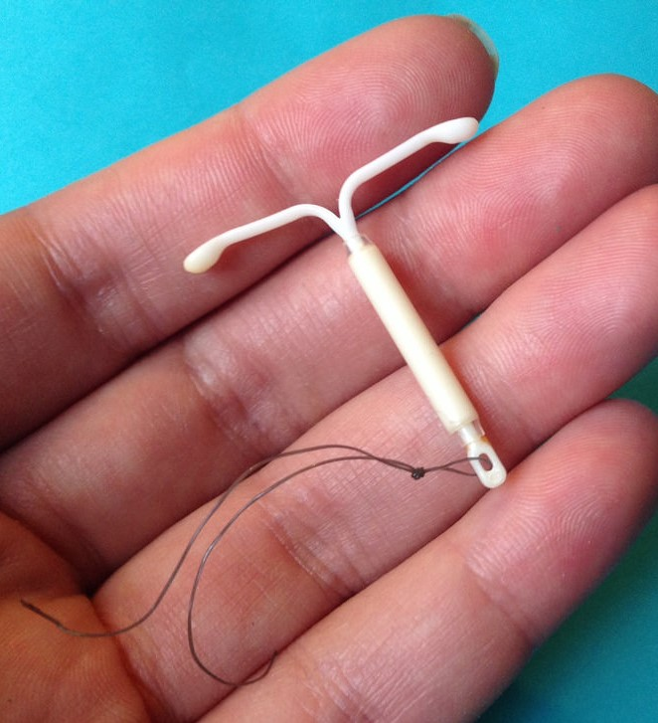 | Contraceptive implant  Implanon NXT™ 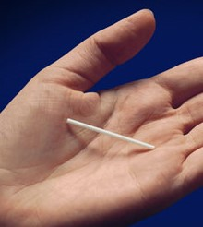
What is it? | - A small plastic and copper contraceptive device that is placed in your uterus by a doctor or a specially trained midwife  - Stops sperm from reaching and fertilising an egg | - A small hormone-releasing contraceptive device that is placed in your uterus by a doctor or specially trained nurse  - Hormones are slowly released and prevent a pregnancy by causing changes to the lining of your uterus, which stops a fertilised egg implanting | - A small plastic rod is placed under the skin of your upper arm by a doctor or nurse (who will also remove it when required)  - Releases a low dose of the hormone progestogen, which stops your ovaries releasing an egg each month
How long does it last? | At least 10 years | 5 years | 3 years
Effectiveness | 99% | 99% | 99%
Benefits | - Not affected by other medications  - Can be easily removed by a trained health professional  - Won’t stop you from getting pregnant later on  - Once inserted, the IUD is the most cost-effective method compared to other methods  - Once removed, you are able to quickly return to fertility  - As effective as sterilisation, but reversible | - Often makes your periods lighter or stops them, although many women experience irregular bleeding in the first few months of use  - Once inserted, the IUD is the most cost-effective method compared to other methods  - Once removed, you are able to quickly return to fertility  - As effective as sterilisation, but reversible | - Your period may become lighter or it may stop  - Can easily be removed  - Won’t stop you from getting pregnant later on
Other considerations | - May make your periods heavier | - Reduces the risk of endometrial cancer | - May cause irregular and troublesome bleeding
Who is it suitable for? | - Safe for most women, including young women and those who have never had children  - Women who are breastfeeding  - Women who prefer a non-hormonal method of contraception | - Safe for most women, including young women and those who have never had children  - Women who are breastfeeding  - Women with endometriosis or excessive bleeding | - Women who are breastfeeding
Only condoms protect against sexually transmissible infections (STIs).

Authorised and published by the Victorian Government, 1 Treasury Place, Melbourne. © State of Victoria, Department of Health and Human Services, January 2019.
Available at <http://healthtranslations.vic.gov.au/>

