Social media pack
Beat the Bite 2022
OFFICIAL

The recent floods in Victoria pose a risk of increased mosquito breeding.
Mosquitos can carry a number of diseases that can make people very ill and, in severe cases, can even cause death.
But simple precautions can help protect your community against mosquitoes and the diseases they may carry.
The social media messages below support your community to understand why it’s important to avoid mosquito bites and how to protect themselves from mosquito borne diseases.
For more information about go to www.betterhealth.vic.gov.au/campaigns/beat-the-bite.

Post text | Channel | Accompanying asset
Mozzie alert  With the recent floods in many areas across Victoria, the risk of mosquito breeding is high.  By following a few simple steps you can reduce your risk of being bitten and getting sick:  Cover up – wear long, loose-fitting clothing. Mozzies can bite through tight clothing.  Use repellents that contain picaridin or DEET on all exposed skin.  Use mosquito nets or insect screens.  Use ’knockdown’ fly spray, mosquito coils or plug-in repellent where you gather to sit or eat.  Limit activity outdoors and move indoors if possible.  Mozzie repellents are your best defence against mosquito bites.  Learn more about how to protect yourself and your family at www.betterhealth.vic.gov.au/campaigns/beat-the-bite  #BeattheBite | Facebook & Instagram | 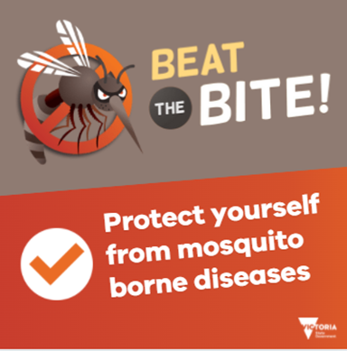
Mosquitoes can breed in even the tiniest amount of stagnant water. With the recent floods, there is a high possibility that you could be at risk of mosquito bites.  If you can’t avoid being around stagnant water, make sure you wear long, lose fitting clothes and use repellents that contain picaridin or DEET on all exposed skin.  More ideas to keep yourself and your family protected:  www.betterhealth.vic.gov.au/health/healthyliving/mosquitoes-protect-your-home-checklist  # BeattheBite | Facebook & Instagram | 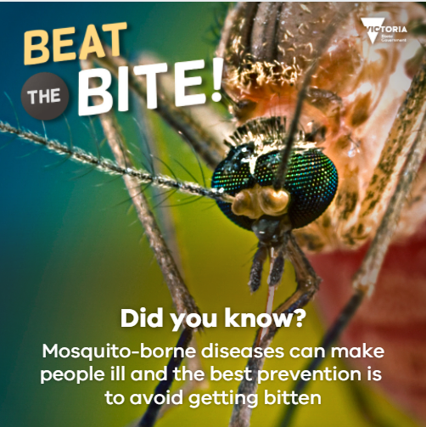
Japanese encephalitis virus alert  Japanese encephalitis (JE) virus can cause a rare but potentially serious infection of the brain and is spread to humans by infected mosquitoes.​  JE virus is transmitted to humans through the bite of an infected mosquito. There is no evidence of transmission from person to person.​  The simplest and best way to prevent JE virus infection during mosquito season is to avoid mosquito bites.  Learn about simple steps to beat the bite:  www.betterhealth.vic.gov.au/campaigns/beat-the-bite  #BeattheBite | Facebook & Instagram | 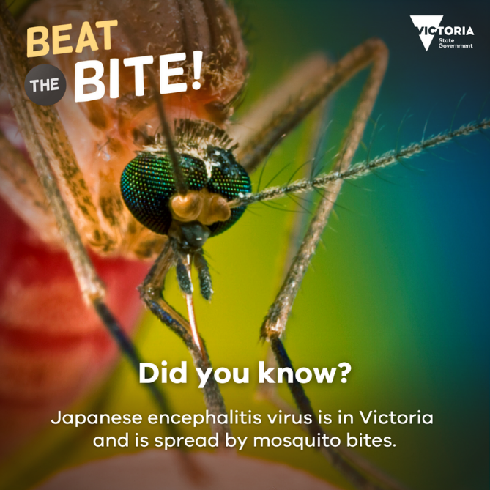
Children are vulnerable to mosquito bites. The recent floods and stagnant water will increase the risk of more mosquitos breeding and spreading disease.  To protect children from mozzies:  Make sure they wear long, loose-fitting clothing outdoors.  Apply a thin, even layer of mosquito repellent to all exposed skin, avoiding hands, eyes and mouth. Choose a lower strength repellent for young children and babies (no more than 20% picaridin or DEET).  If your child has sensitive skin (or is bothered by the smell of DEET) use picaridin or apply repellent to their clothes instead.  Drape a mosquito net over the pram, stroller or infant carrier (make sure there are no gaps).  Find out how you can protect yourself from possible injury, illness, or disease after floods and storms, visit: www.betterhealth.vic.gov.au/health/healthyliving/After-a-flood-returning-home-safely  #BeattheBite | Facebook & Instagram | 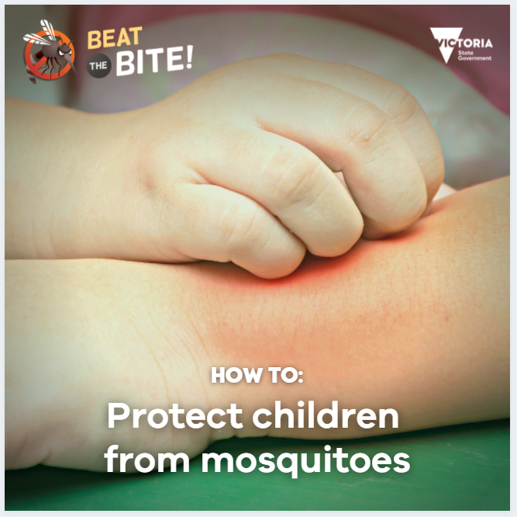
The recent floods will increase the presence of stagnant water. These are the perfect conditions for mosquito breeding.  The good news is, by following a few simple steps you can avoid getting bitten.  Where you can, stay away from places where there is stagnant water.  If you are in a place where there is stagnant water (taking part in recovery efforts and clean up), make sure you wear long, lose fitting clothes and use repellents that contain picaridin or DEET on all exposed skin.  Find out how you can protect yourself from possible injury, illness, or disease after floods and storms, visit: www.betterhealth.vic.gov.au/health/healthyliving/After-a-flood-returning-home-safely  #BeattheBite | Facebook & Instagram | 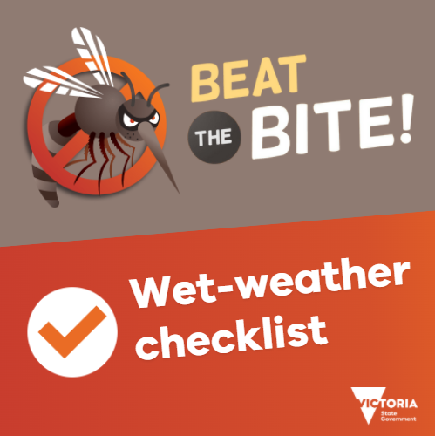

Beat the Bite resources
English and multilingual resources are available for download and use by councils and community organisations to raise awareness of mosquito season at www.betterhealth.vic.gov.au/campaigns/beat-the-bite.
If you would like to order printed resources, please visit our order page at http://ewfds.wfds.com.au/ewfds/?th=CD1&n1=CD001&n2=CD001
The ‘Beat the bite! Protect yourself and your family’ video may be embedded on your website using the YouTube embed code. View it here: https://www.youtube.com/watch?v=NvLOxiigKdc

