Social media copy

The following off-road rider safety content has been developed for social media and can be used alongside the relevant image. The content has been created specifically for the following categories of audiences; younger audience, older audience, bystander (parents, friends of riders) and farm audience.

Simply copy and paste the appropriate text from the category that best aligns with your audience, then upload the corresponding image into your social media post. You can access all social media images in the campaign toolkit section of www.betterhealthchannel.vic.gov.au/ridersafety

Avoid using the thumbnail that appears next to the copy as it is low quality and may appear blurry in your social media post.

Younger off-road rider audience

Photo (do not use thumbnail) | Social media copy
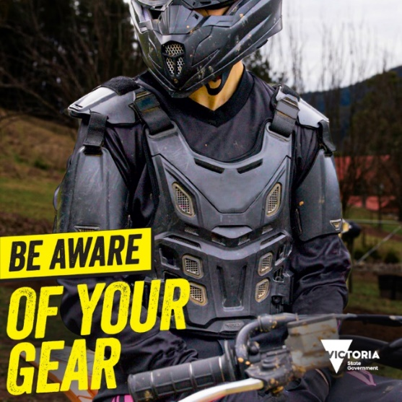 | Head to toe like a pro. Make sure you wear a good fitting helmet, body armour and all the right protective gear, every time you ride. #BeAwareOutThere  Learn more about how to ride safe off-road at www.betterhealth.vic.gov.au/offroadriding
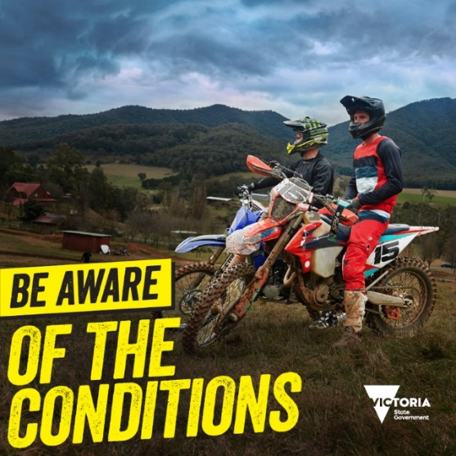 | Things can change in an instant so be alert and check the conditions so you can prepare for the best ride.  If you're a beginner, practice with an experienced rider who can show you the ropes and guide you on unfamiliar trails.  Know the track, nail the ride. #BeAwareOutThere  More tips on ways to ride safe off-road at www.betterhealth.vic.gov.au/offroadriding
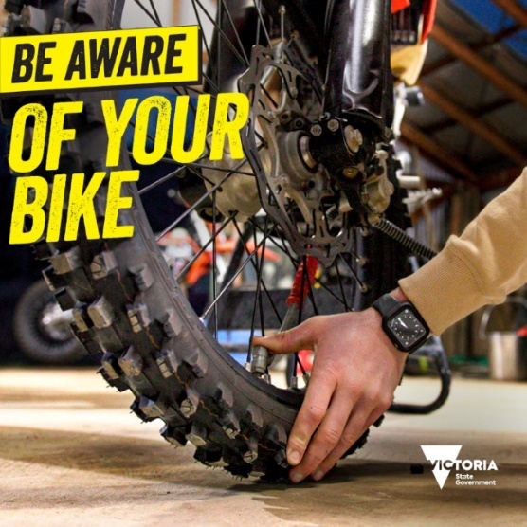 | Prepare your bike for the weather and riding conditions to be safer out there.  Check your headlights and brake lights work, that you have good tread on your tyres, and your throttle doesn’t stick.  And when you're out there, check-in with your mates and look out for the unexpected. #BeAwareOutThere  Learn more about how to ride safe off-road at www.betterhealth.vic.gov.au/offroadriding
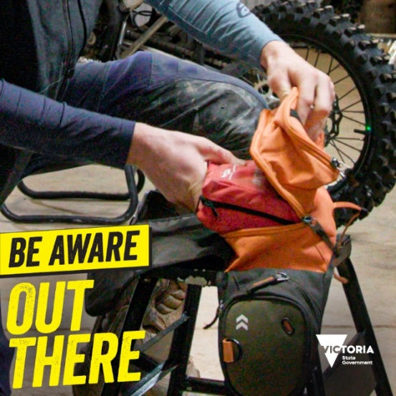 | The only thing you can expect off-road, is the unexpected. Pack your phone and a first aid kit in case you, or a mate, needs help. #BeAwareOutThere  What to be aware of so you can ride safe at www.betterhealth.vic.gov.au/offroadriding
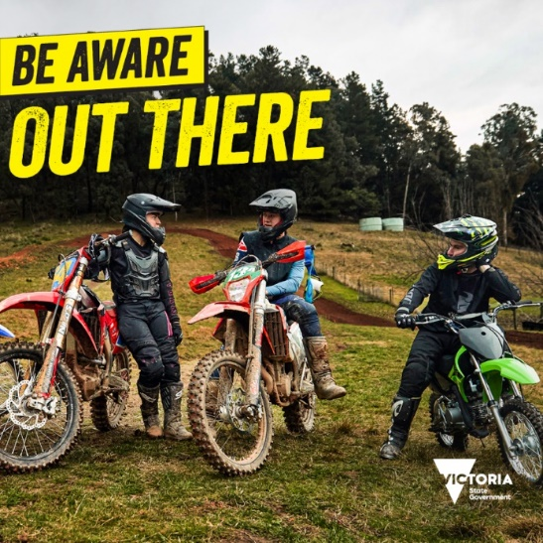 | Being alert can be the difference between having a great day and having a problem. Check-in, prepare and look out for each other. #BeAwareOutThere  Whether you ride in a park or a farm, learn how to ride safer at www.betterhealth.vic.gov.au/offroadriding

Older off-road rider audience

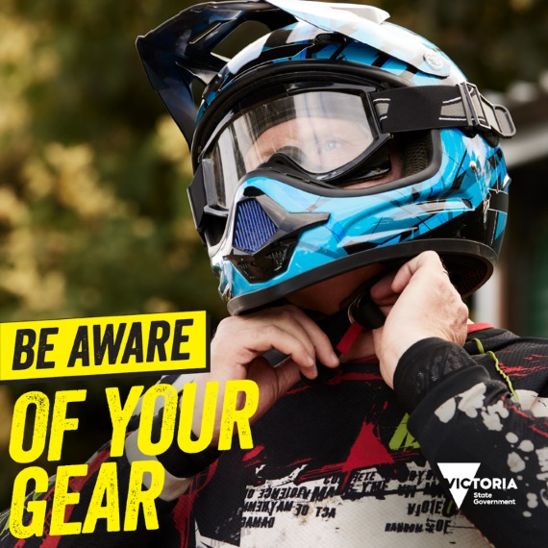 | A good head on your shoulders needs a good helmet. #BeAwareOutThere  Tips on how to be aware out there at www.betterhealth.vic.gov.au/offroadriding
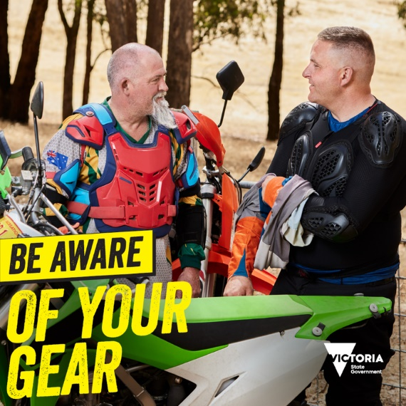 | Wear a good chest guard when you are out there. It helps keep you safe and makes those at home feel better too. #BeAwareOutThere  Learn more about how to ride safe off-road at www.betterhealth.vic.gov.au/offroadriding
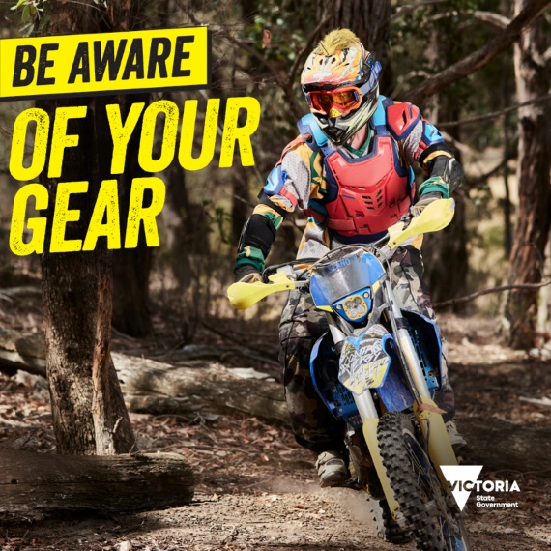 | You can never be too experienced for safety. Match your gear with the conditions out there and wear protective clothing. #BeAwareOutThere  More information about off-road rider safety at www.betterhealth.vic.gov.au/offroadriding
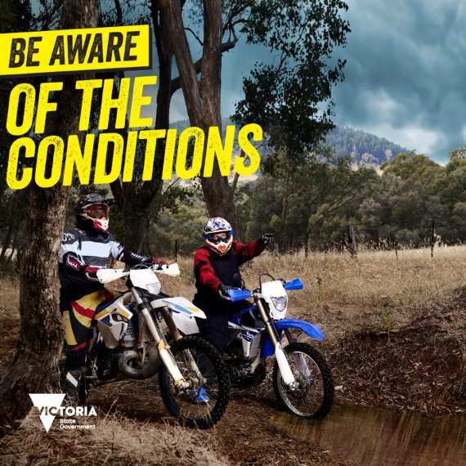 | The best way to protect yourself on the bike is to anticipate and avoid obstacles.  And when the weather changes, so do the conditions.  Stay alert for hazards and unexpected changes on the trail. #BeAwareOutThere  Why you should be aware out there at www.betterhealth.vic.gov.au/offroadriding
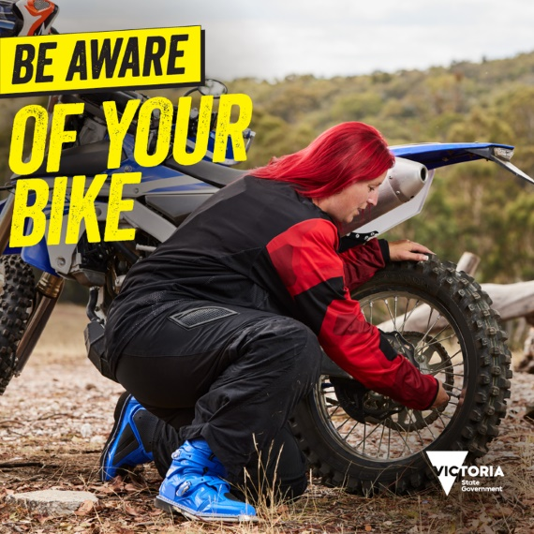 | Prepare your bike for the conditions out there. Check your brakes, that you have good tyre tread and your throttle doesn't stick before you hit the accelerator. #BeAwareOutThere  Find out more at www.betterhealth.vic.gov.au/offroadriding
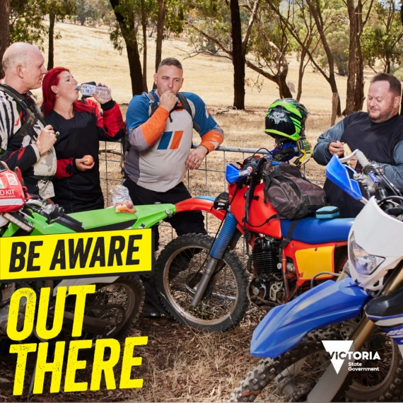 | Anything can happen out there. Remember to carry a first aid kit, phone, and bring snacks and water so you're prepared for the unexpected. #BeAwareOutThere  What to look for out there and more at www.betterhealth.vic.gov.au/offroadriding
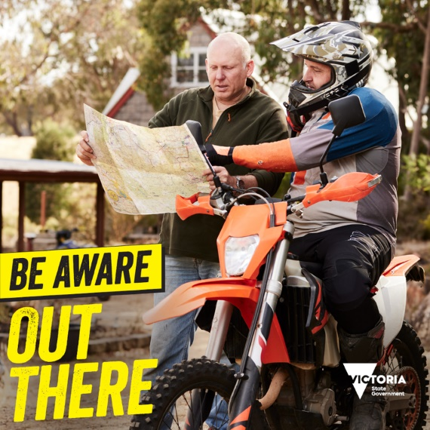 | Before every ride, let people know where you’re headed and be prepared to get help when you need it. #BeAwareOutThere  Learn more about how to ride safe off-road at www.betterhealth.vic.gov.au/offroadriding
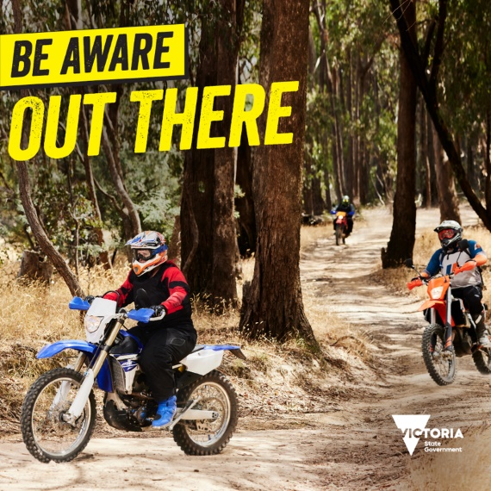 | There’s one thing you can always expect to encounter off-road. The unexpected.  And the only way to prepare for the unexpected is to be aware.  Aware of the terrain and the conditions.  Aware of the condition and performance of your bike, and your safety gear.  Aware of your limitations and the abilities of those you are with.  Aware that being alert could be the difference between having a great day and having a problem.  #BeAwareOutThere.  More info at www.betterhealth.vic.gov.au/offroadriding

Bystander audience

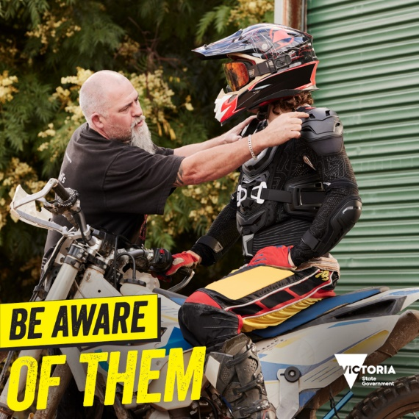 | Before your kids go riding they should prepare their bike and wear full protective gear. Check the tyre pressure, make sure the brakes are functioning properly, and get the chain adjustment right. They should wear a good fitting helmet, good boots, and a chest protector. #BeAwareOutThere  Learn how to be safer out there at www.betterhealth.vic.gov.au/offroadriding
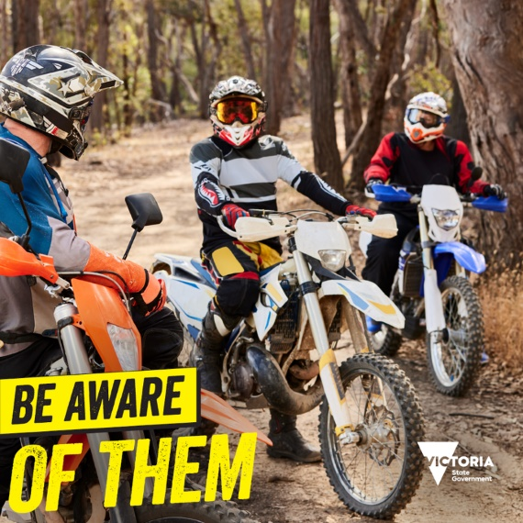 | It’s important for parents to know where their kids are going to be riding, and that they know the terrain and the conditions. Make sure less experienced riders are riding with people that have enough experience. #BeAwareOutThere  Find out more at www.betterhealth.vic.gov.au/offroadriding
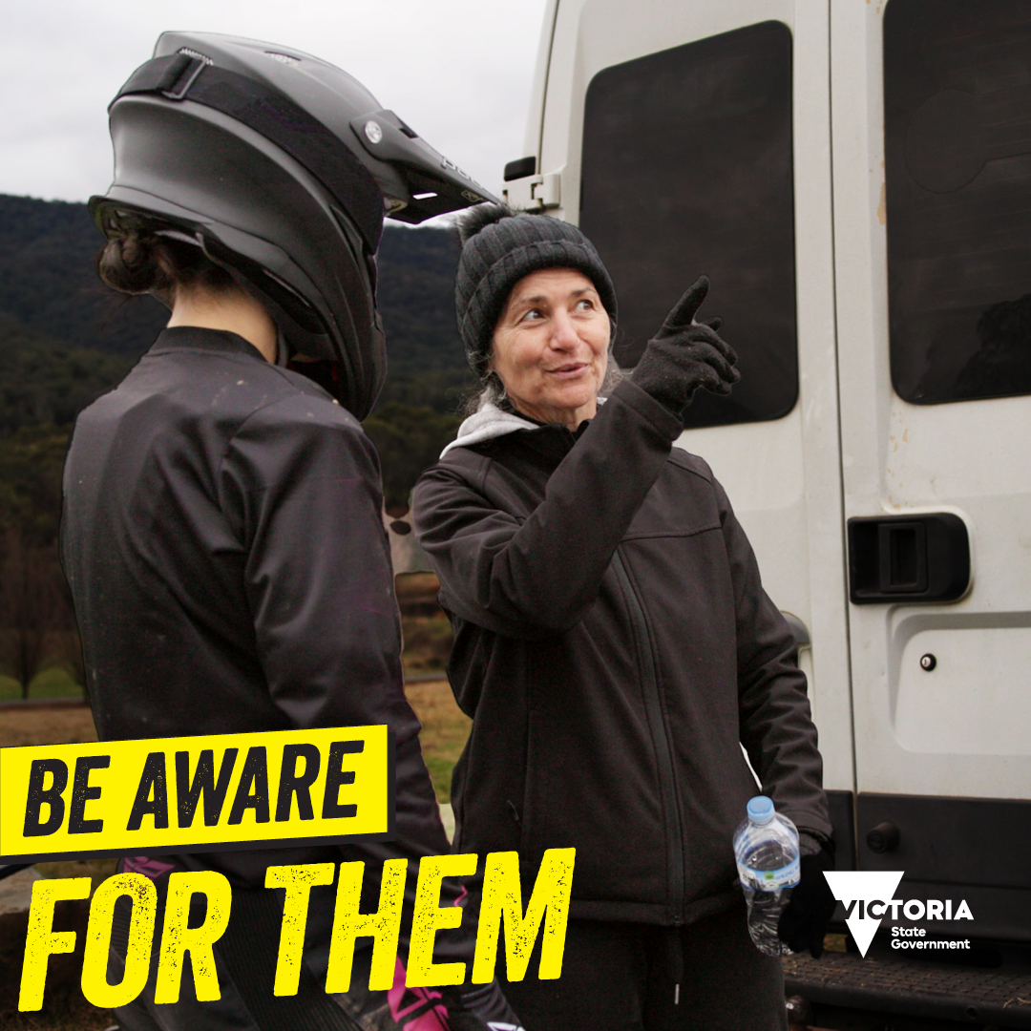 | We all want our loved ones to enjoy every ride. Helping them prepare, take care and be aware out there can be the difference between having a great day and having a problem.  Check they’ve got the right:  ✔️ Protection and riding gear  ✔️ Locations to ride  ✔️ Training and skills  #BeAwareOutThere  Find out more at www.betterhealth.vic.gov.au/offroadriding
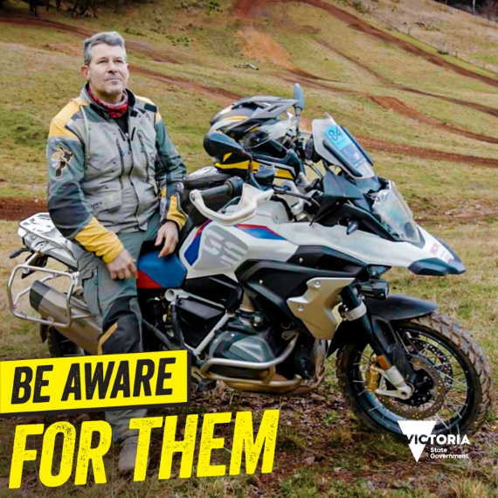 | Veteran off-road motorcyclist Miles Davis shares his top tips for parents who have kids that want to start off-road and dirt bike riding:  ✔️Wear all the gear, all the time  ✔️ Learning takes time and practice  ✔️ Don’t get caught in the hype – make sure they know their limits  ✔️ Check the bike is working properly and safely  #BeAwareOutThere  Find out more at www.betterhealth.vic.gov.au/offroadriding

Farm off-road rider audience

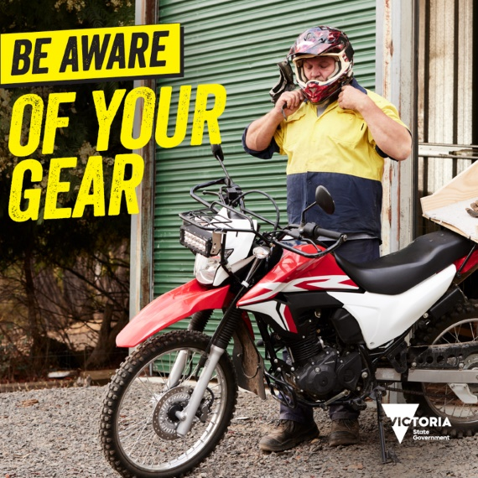 | Always grab your helmet before you go. #BeAwareOutThere  Prepare to be safer out there, visit www.betterhealth.vic.gov.au/ridersafety
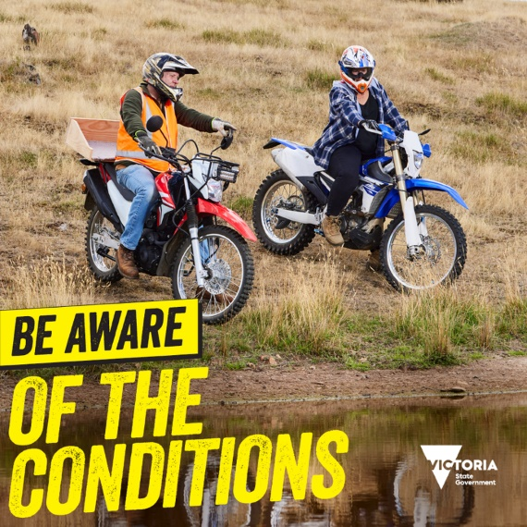 | There’s one thing you can always expect to encounter off-road. The unexpected.  And the only way to prepare for the unexpected is to be aware.  Take care and be aware out there. #BeAwareOutThere  More tips on how to be safe out there at www.betterhealth.vic.gov.au/ridersafety
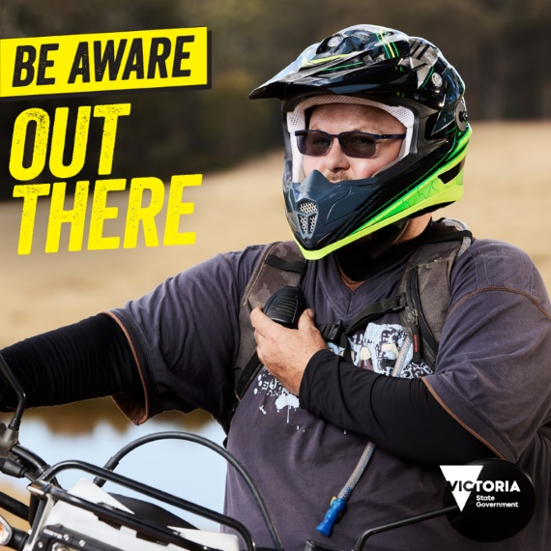 | Stay connected. Grab your phone or walkie talkie so others are aware of where you're at in case you need help. #BeAwareOutThere  More tips on how to be safe out there at www.betterhealth.vic.gov.au/ridersafety
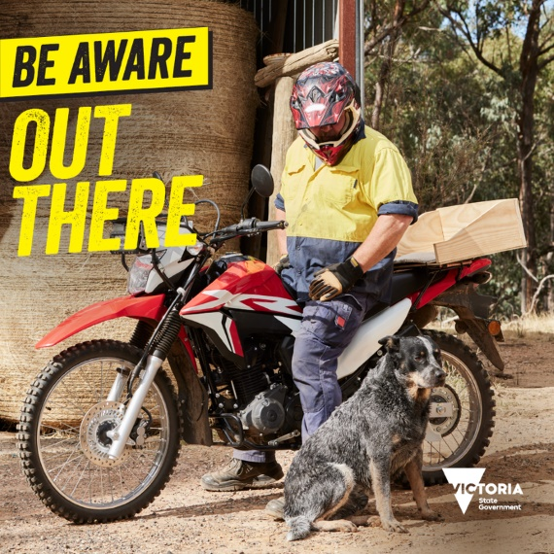 | A farm is a place where anything can happen and usually does.  The only way to prepare is to be aware out there.  Aware of the terrain and the conditions.  Aware of the condition and performance of your bike, and your safety gear.  Aware of your family waiting for you to return, so check in while you’re out there. #BeAwareOutThere  More information at www.betterhealth.vic.gov.au/ridersafety

