Maternal and Child Health
Information for parents with infants and young children
04 January 2022
OFFICIAL

Updates
Version/Date | Changes
1.0 18 October 2021
2.0 19 November 2021 | Removed  Reference to exposure to a Tier 1 or Tier 2 and interstate exposure sites.  Replaced with  ‘are a contact of someone who tested positive’  Added  MCH services and groups are part of essential health service delivery for all parents, children and families to access regardless of their vaccination status.  Parents and caregivers attending first time parents or other MCH groups should be reassured that appropriate screening and safety measures are in place to support the safe inclusion of all parents.
3.0 30 November 2021 | Removed  Face masks are mandatory indoors and outdoors for people aged 12 and over.
4.0 04 January 2022 | Removed  Reference to ‘close contact’  Replaced with  ‘household or household-like contact’  Added  Clients (8 years of age and over) must also wear face masks in these same environments.
In the changing COVID-19 environment, content is often being updated. To ensure you are aware of the most recent changes, all content updates and the date the document was last updated will be highlighted in yellow text.
Please refer to <https://www.coronavirus.vic.gov.au/how-we-live> for current restrictions in metropolitan Melbourne and regional Victoria.

Changes to Maternal and Child Health service delivery due to COVID-19
The COVID-19 pandemic continues to have significant impacts across health services and Victorian communities.
Health services, including some Maternal and Child Health (MCH) services are experiencing significant workforce pressures and shortages, combined with increased service demand.
In line with COVID-19 restrictions and guidance from the Department of Health, some MCH services are also having to prioritise their support to children, mothers/caregivers and families or provide support in different ways.

Prioritising MCH services to vulnerable children and families
Some MCH services, including those in Metropolitan Melbourne and some regional areas, are temporarily prioritising essential services to the most vulnerable children and families including:
- Infants aged 0-8 weeks and their mother/primary caregiver
- Aboriginal infants, children and families
- Children and families with additional needs or concerns including families on the Enhanced Maternal and Child Health Program
This means that in some areas, MCH service delivery for older infants, children and families with no additional needs or concerns may be prioritised towards youngest infants and children first and based on the availability of fully qualified Maternal and Child Health nurses.
All vulnerable children and families are still eligible for MCH appointments across Victoria.
Parents or caregivers with concerns about missed or delayed MCH appointments should contact their regular MCH service to access support.

Alternative supports
Some parents or families may have concerns about missing their next appointment because of changed MCH service delivery arrangements.
Families are encouraged to access alternative supports including:
- Contacting their regular MCH service if they have significant concerns and need their MCH service to proceed
- Call the Maternal and Child Health Line on 13 22 29. The Line is staffed 24-hours, 7-days-a-week by qualified MCH Nurses and provides confidential support and advice about the care and health of your child (from birth to school age).
- Contacting their regular General Practitioner or other regular health professional
- Visiting a SuperCare pharmacy which provides 24-hour, 7-day-a-week access to healthcare advice and pharmacy services, including a free, on-site nursing service from 6-10pm each night.
- Contacting an Optometrist for vision testing
The Victorian Government is providing additional funding to Victorian MCH services so that families who need it, can receive missed or delayed MCH appointments. It is anticipated that options for catch up MCH appointments will be made available by Victorian MCH services commencing in 2022.

Delivering MCH services in different ways
To limit the spread of COVID-19, MCH services are providing services to some families through alternative modes of delivery, including telephone or online consultations and short face-to-face consultations.
Parents and families who are at risk of COVID-19 or have tested positive to COVID-19 or are a household or household-like contact of someone who tested positive, will be offered tele and web-based service delivery in the first instance.
Please contact your local MCH service for information on change of service delivery and remember the 24-hour Maternal and Child Health Line is always available on 13 22 29.

Changes for face-to-face MCH consultations
Prior to attending any face-to-face consultation, MCH services will ask questions to assess if you are at risk of COVID-19, have tested positive to COVID-19 or if you are a household or household-like contact of someone who tested positive for COVID-19.
Individuals or families that are assessed at risk of COVID-19, have tested positive to COVID-19 or are a household or household-like contact of someone who tested positive for COVID-19 will be offered tele and web-based options to deliver services in the first instance.
In MCH services with modified service delivery, face to face MCH consultations will be limited to only essential family members i.e. mother/primary carer and infant/child only.

Face masks and MCH consultations
In line with advice from the Chief Medical Officer, during face-to-face consultations MCH nurses will be wearing personal protective equipment (including face masks and eye protection) to limit the risk of transmission of COVID-19.
You will also be asked to wear a face mask during your face-to-face MCH consultation whether that is at a MCH centre or in your own home if a MCH nurse is visiting.
Clients (8 years of age and over) must also wear face masks in these same environments.
Children under two years should never wear a face mask due to choking and strangulation risks.

MCH services and group work
MCH services and groups are part of essential health service delivery for all parents, children and families to access regardless of their vaccination status.
Parents and caregivers attending first time parents or other MCH groups should be reassured that appropriate screening and safety measures are in place to support the safe inclusion of all parents.

COVID-19 vaccinations - Can I have a COVID-19 vaccine if I am pregnant, breastfeeding or planning pregnancy?
Yes, the Pfizer and Moderna vaccines are now routinely recommended for women who are pregnant, breastfeeding or planning pregnancy. Pregnant and breastfeeding women are now a priority population for vaccination. This is a joint recommendation from the Australian Immunisation Technical Advisory Group and the Royal Australian and New Zealand College of Obstetricians and Gynaecologists.
Research shows Pfizer and Moderna are safe for pregnant and breastfeeding women and they can receive the vaccine at any stage of pregnancy. Please refer to https://www.health.gov.au/resources/publications/pregnancy-breastfeeding-and-covid-19-vaccines-english for further information.

COVID-19 - babies and children
We understand that many parents may be feeling anxious or concerned about their children’s health and wellbeing during the COVID-19 pandemic. As usual, parents should take care with babies because of their developing immune systems. But as far as we know about COVID-19 parents should be reassured that most young children and infants don’t become seriously sick if they get infected.

Make sure childhood vaccinations are up to date
Routine vaccination is the safest, most effective way to protect babies and children from illness.
Keep your child’s vaccinations up to date to minimise the chance they’ll need medical attention while the health system is dealing with the COVID-19 pandemic.

Maintain good hygiene for you and your baby
The best thing you can do is to maintain good hygiene for yourself and your family by doing the following:
- cover your coughs and sneezes with your elbow or a tissue
- dispose of tissues properly
- wash your hands often with soap and water, including before and after eating and after going to the toilet
- use alcohol-based hand sanitisers and putting them safely away from young children
- clean and disinfect surfaces
- if you are sick, avoiding contact with others
- clean and sanitise frequently used objects such as mobiles, keys and wallets.
Because babies put their hands in their mouths, frequently washing their face and hands, and cleaning surfaces and objects they might touch will help protect them from any infection.

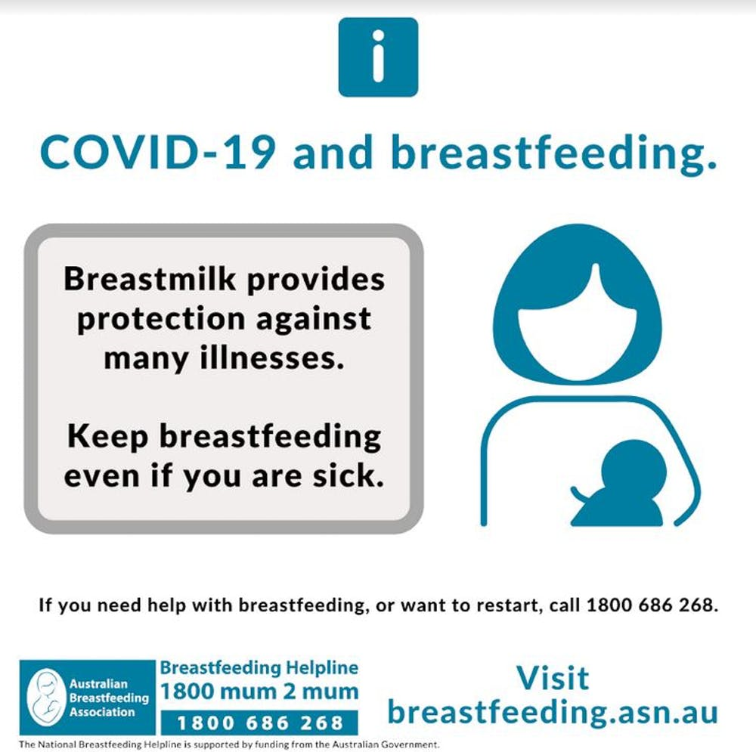
Feeding your baby

Should I continue with breastfeeding?
You might be wondering if you should continue to breastfeed, especially if you are unwell.
Breast milk contains many ingredients to help prevent and fight infection. It is recommended babies be fed only breast milk until they are six months old and continue breastfeeding with other foods into their second year of life.
The latest advice from the Australian Breastfeeding Association is to keep breastfeeding, even if you are unwell <www.breastfeeding.asn.au/bfinfo/covid-19>.
If your baby is under six months and breastfeeding, offering them only breast milk protects them from a range of infections and reduces their need for medical treatment or hospitalisation.
If your baby is breastfeeding and using formula, think about replacing formula feeds with breastfeeds. Talk to your MCH nurse, general practitioner (GP) or paediatrician for advice.
If you have stopped breastfeeding altogether, it is possible to start breastfeeding again if you want to. Call the national Breastfeeding Helpline on 1800 686 268 for help.

What if I’m using formula?
It is easy to accidentally introduce germs into bottles when preparing infant formula.
Be extra careful about preparing bottles. This means always washing your hands thoroughly with soap, washing bottles thoroughly, sterilising them after every use, and making up formula with boiled water cooled to lukewarm or room temperature. Refer to Infant formula <https://raisingchildren.net.au/newborns/breastfeeding-bottle-feeding/bottle-feeding/formula-making-storing-transporting> for instructions on formula making.
Remember before feeding your baby, test the temperature of the formula by placing a few drops on the inside of your wrist. It should feel warm, not hot.

How can I access formula?
You can access formula through supermarkets, pharmacies, online stores or contacting formula companies directly.
If you are unable to access formula, please contact your MCH service or the MCH Line on 13 22 29 for further advice.
If you are having difficulty accessing your regular brand of infant formula and buy another brand, ensure that you read the preparation instructions carefully as dosages can vary between brands.
In Australia, commercial infant formula or baby formula is the only safe alternative to breastmilk for infants for the first 12 months. Every infant formula you can buy in Australia meets strict Australian standards.
The following milks should not be the main milk source for babies under 12 months of age:
- normal cow’s milk
- skim evaporated, powdered or sweetened condensed milk
- dairy alternatives like soy, rice, almond or coconut milk.
Homemade infant formula or diluted milks (of any of the above) are not a safe alternative to breastmilk or commercial infant formula for babies under 12 months.
The use of ‘follow-on formula’ for infants aged 6–12 months is not considered necessary and no studies have shown advantages over using ‘infant formula 0–6 months’.
The use of formula for infants at risk of allergy or with cow’s milk allergy needs to be on the advice of MCH nurse, GP or paediatrician.

What happens if someone in the family gets COVID-19?
Mothers are more at risk of becoming sick from COVID-19 than their infants. If you are breastfeeding and you contract COVID-19 it is recommended you continue breastfeeding as the virus has not been found in breastmilk.
Wearing a mask when you are with your infant (including during feeding), washing hands before and after contact with your infant, and cleaning and disinfecting surfaces and any feeding equipment will help prevent your infant catching the virus from you.
Mothers, if you are hospitalised or separated from your infant, you can express breastmilk for them.
Family members who need to isolate must stay at home and not attend public places, work, school, childcare or university.
For more information visit <Your COVID Checklist | Coronavirus Victoria - What to do if you test positive to COVID-19 or if you've been told you are a contact > on the Department of Health website.

Other supports available for parents and carers
Talk to your local MCH services to find out more about what supports are available in your local area.
You can get more support or advice from:
- Maternal Child Health Line - 13 22 29
https://www.betterhealth.vic.gov.au/health/serviceprofiles/maternal-and-child-health-line-service
A free and confidential service available to parents and families with children ranging from birth to starting school age. The MCH line is staffed by qualified MCH nurses. You can call 24 hours a day, 7 days a week to get information, support and guidance on a range of issues like child health, nutrition, breastfeeding, maternal and family health and parenting.
- Raising Children Network https://raisingchildren.net.au/
Provides parenting videos, articles and apps backed by Australian experts. They also have information for parents and carers about COVID-19 https://raisingchildren.net.au/guides/coronavirus-covid-19-guide
- Nurse on Call - 1300 606 024
https://www2.health.vic.gov.au/primary-and-community-health/primary-care/nurse-on-call
Get expert health advice from a registered nurse, 24 hours a day, 7 days a week.
- Parentline - 13 22 89
https://www.education.vic.gov.au/parents/services-for-parents/Pages/parentline.aspx
A free and confidential telephone counselling service available to Victorian parents and carers of children aged from birth to 18-years-old. Parentline is staffed by social workers and psychologists and is available from 8am to midnight, 7 days a week. The service offers information on a variety of parenting issues and can help parents to develop strategies for positive parenting and personal coping.
- Breastfeeding helpline - 1800 686 268 (1800 mum2mum)
https://www.breastfeeding.asn.au/breastfeeding-helpline
The Australian Breastfeeding Foundation’s national breastfeeding helpline.
- Care Ring - 13 61 69
https://www.unitingkildonan.org.au/programs-and-services/financial-support/carering/
A Victorian service staffed by volunteers trained to respond to concerns and emergencies, including domestic violence, family matters, child abuse, depression and anxiety, loneliness, unemployment, grief, homelessness, money worries, drug and alcohol problems, and suicide.
- Council of Single Mothers and their Children Support Line - (03) 9654 0622 or 1300 552 511 outside Melbourne
https://www.csmc.org.au
A support service staffed by professional single mothers with lived experience who can provide advice and info on Government benefits, dealing with Centrelink, Family Court and Child Support Agency, parenting solo, housing, family violence, managing money, and work and study. Interpreting services available for women of non-English-speaking background.
- Lifeline - 13 11 14
https://www.lifeline.org.au/
A 24-hour confidential crisis support service responding to a range of concerns including anxiety, depression, abuse, suicidal thoughts and stress.
- Women's Information & Referral Exchange (WIRE) - 1300 134 130 or live chat
https://www.wire.org.au/find-support/
A free and confidential telephone service provided for women by women offering information and referral on any issue including violence, sexual assault, relationships, the law, finance, health, family matters, drugs and alcohol, sexual harassment, employment and sexuality. Interpreting assistance is available for women of non-English-speaking background.
- PANDA Helpline - 1300 726 306
https://www.panda.org.au/info-support/pandas-national-perinatal-anxiety-depression-helpline
PANDA’s National Perinatal Anxiety & Depression Helpline is Australia’s only free, national helpline service for women, men and their families affected by perinatal anxiety and depression. The Helpline provides a safe and confidential space for any new or expecting parent struggling with the challenges of becoming a new parent.

To receive this document in another format phone 1300 651 160 using the National Relay Service 13 36 77 if required, or email Maternal and Child Health and Parenting <mch@health.vic.gov.au>.
Authorised and published by the Victorian Government, 1 Treasury Place, Melbourne.
© State of Victoria, Australia, Department of Health, 4 January 2022.
Except where otherwise indicated, the images in this document show models and illustrative settings only, and do not necessarily depict actual services, facilities or recipients of services. This document may contain images of deceased Aboriginal and Torres Strait Islander peoples.
Available at: health.vic - Maternal and Child Health Service <https://www2.health.vic.gov.au/primary-and-community-health/maternal-child-health>.

