ការប្រែប្រួលអាកាសធាតុ និងសុខភាព - ការរក្សាសុខភាពការបានល្អ ក្នុងបរិស្ថានអាកាសធាតុប្រែប្រួល

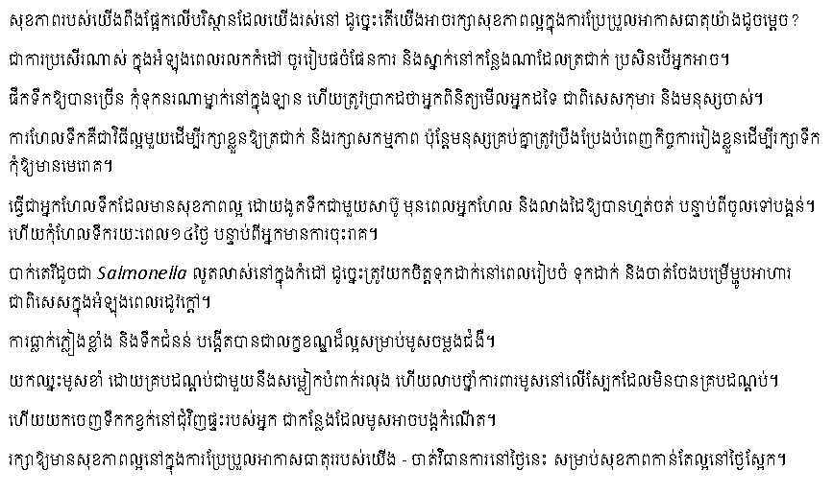

To receive this publication in an accessible format phone 1300 761 874 using the National Relay Service 13 36 77 if required, or email environmental.healthunit@health.vic.gov.au
Authorised and published by the Victorian Government, 1 Treasury Place, Melbourne.
© State of Victoria, Department of Health, October 2021.
Available from the Climate change and health – Staying healthy in a changing climate (video) page <https://www.betterhealth.vic.gov.au/health/Videos/Climate-change-and-health-staying-healthy-in-a-changing-climate> on the Better Health Channel website.

