Contraception methods
Barrier methods of contraception

You have to remember to use these methods every time you have sex
Method | Male condom  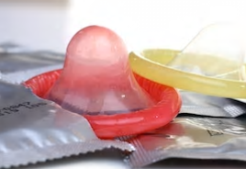 | Female condom  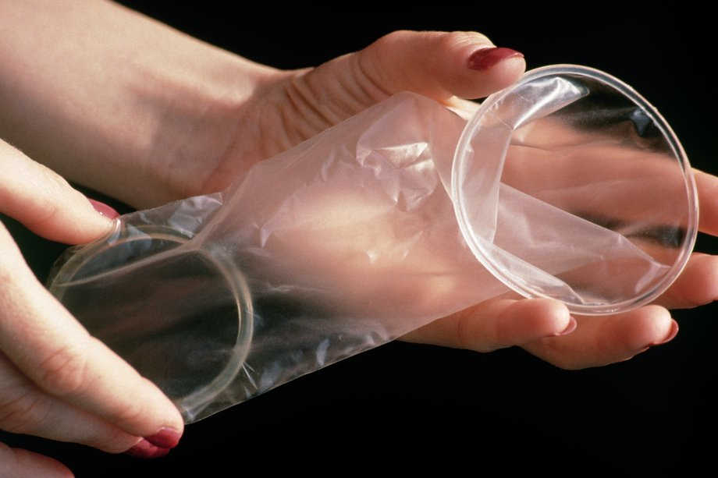 | Diaphragm (Caya™)  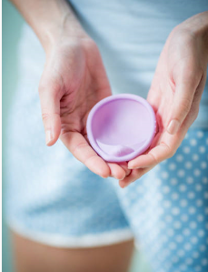
Effectiveness* | - Perfect use: 98%  - Typical use: 82% | - Perfect use:95%  - Typical use: 79% | - Perfect use: 86%  - Typical use: 82%
What is it? | - A latex (or polyurethane) covering that is put over the erect penis, stopping sperm from getting into the vagina. | - A loose polyurethane pouch that sits in the vagina.  - Has a flexible ring at each end (the inner end is closed).  - Stops sperm from getting into the uterus.  - Available from Family Planning Victoria [https://www.fpv.org.au/] (by mail order) and some retail outlets and sexual health clinics. | - A soft, shallow, single-size silicone dome that fits in the vagina.  - Covers the opening to the uterus, stopping sperm from getting through.  - Can be bought online, from some family planning clinics and pharmacies.
How often do you use it? | - Put on every time before intercourse or before any contact between the penis and the vagina.  - One use only. | - Put in every time before intercourse or before any contact between the penis and the vagina.  - One use only. | - Should be inserted before sex and left in for six hours afterwards.
Benefits | - Provides the best protection against sexually transmissible infections. | - Can be put in several hours before sex.  - Stronger than the male latex condom.  - Protects against sexually transmissible infections. | - Re-useable.  - Should be replaced after two years.
Other considerations | - Remove carefully afterwards.  - Easily available from:  - pharmacies  - supermarkets  - sexual health clinics  - vending machines (in some locations). | - May take some practice to use correctly.  - Remove carefully afterwards.  - Slightly more expensive and less readily available than male condoms. | - The single size diaphragm fits most women.  - See a doctor or nurse to check that the diaphragm is a good fit for you.
* Perfect use = when used exactly as intended
* Typical use = when not used perfectly.

Authorised and published by the Victorian Government, 1 Treasury Place, Melbourne. © State of Victoria, Department of Health and Human Services, January 2019.
Available at <http://healthtranslations.vic.gov.au/>

