As Victorians start to enjoy the great outdoors and our beautiful regional attractions again during summer, there are some simple steps everyone can take to reduce their risk of being bitten by mosquitoes. While most mosquitoes are just a nuisance, some can carry disease.
Social media posts for community groups and Councils
The Department of Health and Human Services has developed these social media posts to help your organisation share information about how everyone can Beat the bite!
Beat the bite!

Social media posts
In addition to ordering printed posters to display around the community, the following sample Facebook and Twitter posts can be tailored to local areas/events and shared on registration pages, Council websites and stakeholder sites. The text highlighted in grey should be amended and the highlight removed before sending out.
You can also follow us on Facebook (https://www.facebook.com/BetterHealthChannel) and Twitter https://twitter.com/betterhealthgov to share a range of tips on how to Beat the bite!

Sample Facebook posts
- The best protection from mosquito-borne diseases is to avoid mosquito bites. For more information: https://www.betterhealth.vic.gov.au/campaigns/beat-the-bite
- Planning to attend the xxx event? Don’t forget to bring insect repellent as well as (add tips related to the context of your event, for example, sunhat, water etc and requirements related to current COVID-19 regulations). https://www.betterhealth.vic.gov.au/campaigns/beat-the-bite
- Mosquitoes breed in stagnant water. Follow these simple steps to stop mosquitoes breeding around your home. https://www.betterhealth.vic.gov.au/campaigns/beat-the-bite

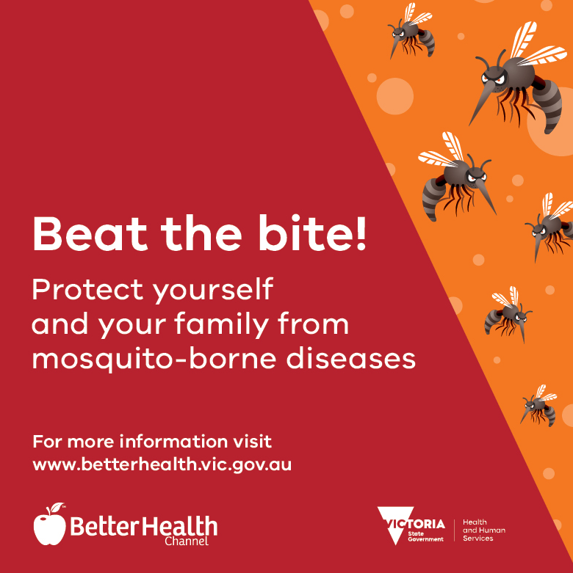
Hashtag: #BeatTheBite

Translations
The Beat the bite social media tile is now available in 30 community languages including: Amharic, Arabic, Assyrian, Bengali, Burmese, Dari, Dinka, Farsi (Persian), Filipino/Tagalog, Greek, Gujarati, Hindi, Indonesian, Italian, Khmer, Korean, Macedonian, Malayalam, Nepali, Punjabi, Samoan, Simplified Chinese, Sinhalese, Somali, Spanish, Tamil, Traditional Chinese, Turkish, Urdu and Vietnamese. https://www.betterhealth.vic.gov.au/campaigns/beat-the-bite

Sample Twitter posts
- The best protection from mosquito-borne diseases is to avoid mosquito bites: https://www.betterhealth.vic.gov.au/campaigns/beat-the-bite

- There are some simple steps to stop mosquitoes breeding around your home. #BeatTheBite https://www.betterhealth.vic.gov.au/campaigns/beat-the-bite

- Let’s work together to reduce mosquito numbers this summer #BeatTheBite https://www.betterhealth.vic.gov.au/campaigns/beat-the-bite

