Beat the bite!
Reducing mosquito-borne diseases
Toolkit information sheet

About this toolkit
While most mosquitoes are just a nuisance, some can carry diseases including Ross River virus, Barmah Forest virus, and Murray Valley Encephalitis (MVE) – all serious, infectious and in the case of MVE, potentially life-threatening.
As Victorians start to enjoy the great outdoors and our beautiful regional attractions again during summer, there are some simple steps everyone can take to reduce their risk of being bitten by mosquitoes.
The Department of Health and Human Services has developed this toolkit to help your organisation share information about how everyone can Beat the bite!
We want to reach anyone who lives in, or travels to, areas where mosquito numbers can be high or where diseases have been detected. This potentially includes all Victorian residents and visitors, whether they’re on holidays or working outdoors anywhere across the state but is most likely to be concentrated in particular areas.

What’s in this toolkit?
This toolkit includes the following resources to help promote Beat the bite! information to the community during the summer season. These are all available at: https://www.betterhealth.vic.gov.au/campaigns/beat-the-bite
- Tips for promoting messages
- Digital and printed resources
- Translated resources
- Social media tiles and suggested posts for public audiences (including translations)
- Sample article text.

Tips to help promote Beat the bite!

It’s better to be prepared
Heavy rains and warmer weather can provide the ideal breeding ground for mosquitoes, so if these events occur, it’s time to prepare. Whether it’s holidaymakers packing for a camping holiday or a council getting ready to welcome tourists, now is the time to get the messages out about packing insect repellent, checking public areas and homes for obvious mosquito breeding sites and getting prevention messaging and activities underway.
What are the events coming up over summer where Beat the bite! messages could be promoted? If outdoor events are planned, consider ordering brochures and posters to display and adding reminders about bringing insect repellent and the other preventive steps on event information and registration pages.

Watch for advice and warnings
If a mosquito-borne disease is detected and it’s considered a risk to public health, the Chief Health Officer may issue a health warning and this information is usually shared by local media. While local reports of large numbers of mosquitoes can cause concern, it’s important to remind everyone that the risk of them carrying diseases is low, and there are simple ways to avoid being bitten.

Localise your message
Use your local knowledge to make your messages more meaningful to your audience. If large numbers of mosquitoes are reported in your area, this is an opportunity to remind residents and visitors of the easy steps they can take to avoid being bitten. Where councils undertake control activities, this can also be promoted. We have an important role to play in supporting communities to be aware of, but not alarmed about, mosquito-borne diseases.

Consider your tone
2020 has been a very difficult year for everyone. As we’re now able to enjoy more freedom of travel around Victoria and beyond, the last message anyone wants to hear is that their health will be at risk if they spend time outdoors enjoying the natural beauty of our state. The aim is to make people aware of the risks and know the simple steps to protect themselves and their family. This will help ensure they get the most of their outdoor activities, whether it’s for work or play.

Consider your channels
- Think about targeting groups that are vulnerable to mosquito bites including tourists, outdoor workers, the elderly and the very young.
- Explore sharing information via school newsletters, event registrations, church noticeboards, council venues, sporting clubs and venues.
- Order printed posters and brochures to place in public places and community buildings.
- Consider social media. It’s an important channel for some audiences.
- Provide insect repellent containing DEET or picaridin to any guests and staff if you’re running any kind of outdoor event or workplace, including sporting and recreational activities.

Digital resources
A wide range of resources, including factsheets, videos and posters, are available at:
https://www.betterhealth.vic.gov.au/campaigns/beat-the-bite

Printed resources
The following printed resources can be ordered at no cost by clicking on the
link here: https://www.betterhealth.vic.gov.au/campaigns/beat-the-bite
Beat the bite! poster –
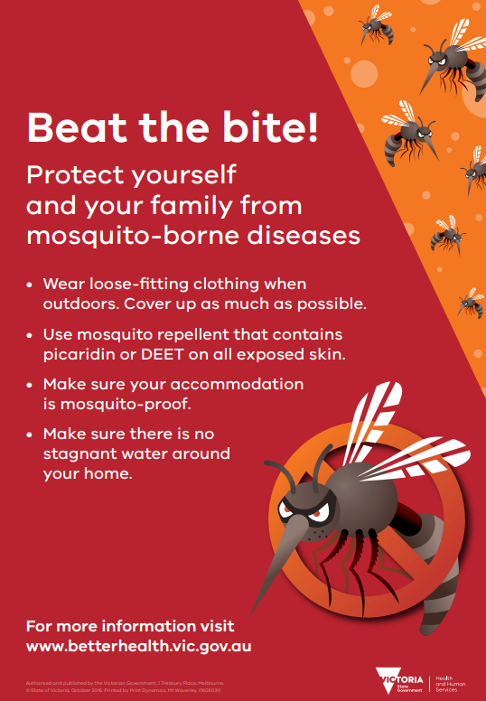
Beat the bite! brochure –
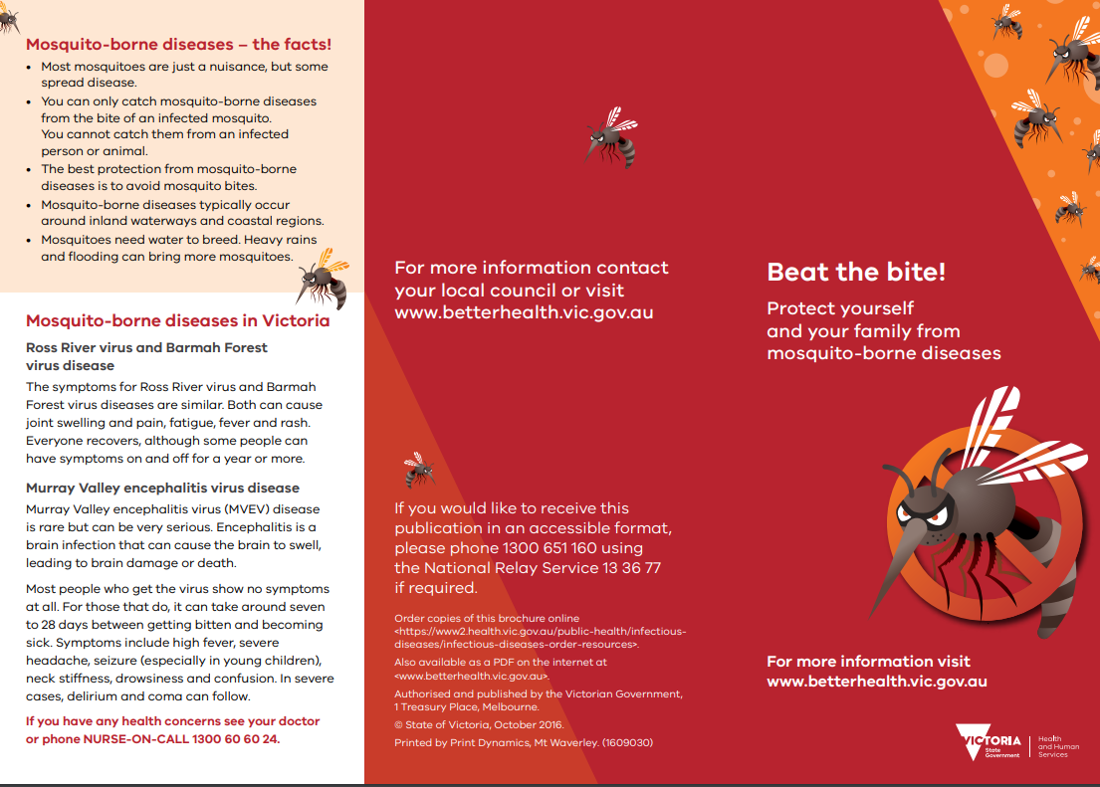

Translated resources
The Beat the bite! poster, together with a range of social media posts, has been translated into 30 community languages and is available at:
https://www.betterhealth.vic.gov.au/campaigns/beat-the-bite

Sample article text
This sample article can be used by councils and community groups in newsletters or websites to help their readers know how to Beat the bite! Councils may also wish to include information about any control measures they’re undertaking to reduce mosquito numbers in their area.
Contacts
If you have any questions related to this information, please contact the Department of Health and Human Services vector-borne infectious diseases control program at infectious.diseases@dhhs.vic.gov.au.

