Contraception methods
Medium acting and short acting contraception methods

Method | Contraceptive injection  Depo-ProveraTM or Depo – Ralovera, (also known as “depo”)  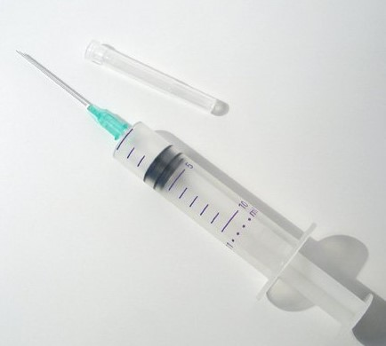 | Vaginal ring | Combined oral contraceptive pill | Mini pill  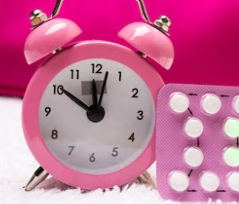
Effectiveness* | - 94% | - Perfect use: 99%  - Typical use: 93% | - Perfect use: 99%  - Typical use: 93% | - Perfect use: 99%  - Typical use: 93%
What is it? | - An injection provided by a doctor or nurse.  - Contains a progesterone-like hormone.  - Stops ovulation and makes the fluid at the opening to the uterus thicker, stopping sperm from getting through. | - A ‘one size fits all’ ring placed into the vagina.  - Slowly releases hormones that move from the vagina into the bloodstream to prevent pregnancy.  - Replaced every four weeks (after the week off when you have your period). | - Synthetic hormones prescribed by a doctor.  - Stops ovulation and makes the fluid at the opening to the uterus thicker, stopping sperm from getting through. | - Has a synthetic form of one hormone; prescribed by a doctor.  - Makes the fluid at the opening to the uterus thicker, stopping sperm from getting through.
How long does it last? | - Medium acting - you don’t have to remember to use it every time you have sex  - It lasts 12–14 weeks | - Medium acting - you don’t have to remember to use it every time you have sex  - After three-weeks the ring is taken out and a new ring is put in one week later. | - Short acting - you have to remember to take it every day | - Short acting - you have to remember to take it every day at the same time.
Benefits | - No one can tell that you are using it.  - Can be used while breastfeeding.  - Not affected by other medications.  - Your period may become lighter or it may stop. | - You insert it yourself, and it is as easy to put in as a tampon.  - Can make periods lighter and less painful.  - Does not affect your fertility. | - Can be used to skip periods. | - Suits those who cannot take oestrogen for health reasons.  - Can be used while breastfeeding.
Other considerations | - You need to remember to have another dose, on time, every 12 to 14 weeks, otherwise its effectiveness is reduced.  - May take some months to return to normal periods and fertility once you stop using it.  - May cause a decrease in bone density. | - Not recommended if you are at risk of heart disease, such as smokers who are over 35 years of age. | - Can reduce the risk of endometrial and ovarian cancer. | - May not be as effective as the combined pill, because it must be taken strictly on time.  - Can cause some side effects.
Who can use it? | - Safe to use if you are breastfeeding, but may reduce the amount of breastmilk if your baby is younger than six months. | - Can be used from 21 days after childbirth. | Not recommended for those who are at risk of heart disease, such as smokers who are over 35 years of age. | Not suitable in the presence of some medical conditions (such as breast cancer) or certain medications.
* Perfect use = when used exactly as intended.
* Typical use = when not used perfectly.
Further information
Only condoms protect against sexually transmissible infections (STIs).
Authorised and published by the Victorian Government, 1 Treasury Place, Melbourne. © State of Victoria, Department of Health and Human Services, January 2019.
Available at <http://healthtranslations.vic.gov.au/>

