Contraception methods in Australia
Using contraception can help you prevent a pregnancy. Different methods may suit you at different times in your life.

Long-acting reversible contraception (LARC)

LARC contraceptive methods provide temporary, safe, effective contraception over a number of years. There are two types:
- The contraceptive implant is a small plastic rod that is placed under the skin of your upper arm, releasing a low dose of a hormone and stopping your ovaries releasing an egg each month. It lasts for three years and can easily be removed by a doctor or a nurse.

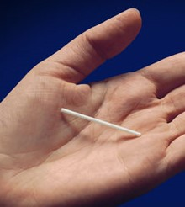

- The intrauterine device (IUD) is a small contraceptive device that is placed in your uterus. There are two kinds of IUD. The copper IUD lasts for five to 10 years. The hormone-releasing IUD lasts for five years. An IUD stops sperm from reaching and fertilising an egg. It also changes the lining of your uterus, so a fertilised egg won’t embed in it. An IUD can easily be removed by a doctor or nurse.

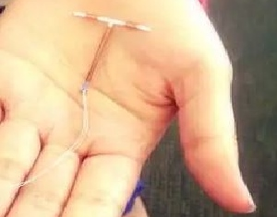

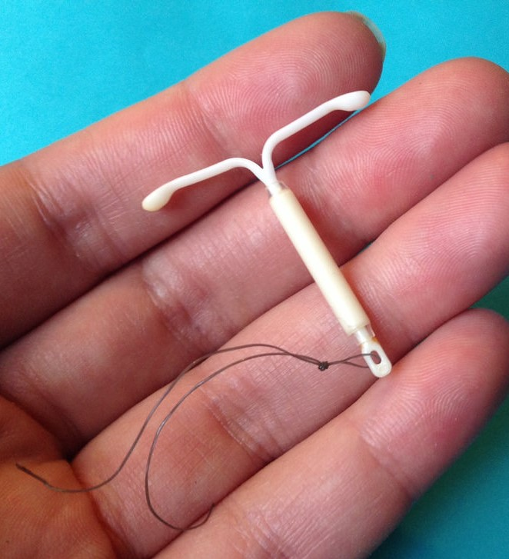

Medium-acting methods of contraception

Medium-acting contraceptive methods provide temporary, safe, effective contraception over a period of weeks or months. There are two types:
- The contraceptive injection (also known as Depo) is a hormonal injection. It contains a hormone that stops ovulation. For it to be effective, you will need to have the injection every 12 to 14 weeks.

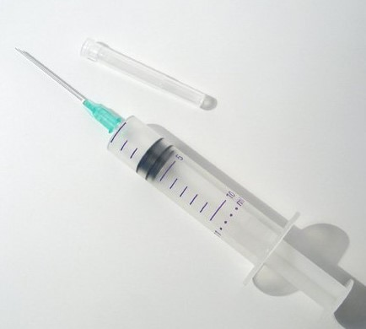

- The vaginal ring contains hormones that prevent ovulation. It is a ‘one size fits all’ ring that stays in place in the vagina for three weeks. After this three-week period you take the ring out, then insert a new ring one week later.

Short-acting methods of contraception

Short-acting contraceptive methods provide temporary, safe, effective contraception. They need to be taken every day. There are two types:
- The combined contraceptive pill, which must be taken every day, contains synthetic forms of two hormones. They stop ovulation and make the fluid at the opening to the uterus thicker, stopping sperm from getting through.

- The mini pill contains a synthetic form of only one hormone. It makes the fluid at the opening to the uterus thicker, stopping sperm from getting through. It needs to be taken every day at the same time.

Barrier methods of contraception

Barrier methods of contraception stop sperm from getting into the uterus. They include:
- male condoms
- female condoms
- diaphragms.
Condoms provide protection from sexually transmissible infections.
Male condom  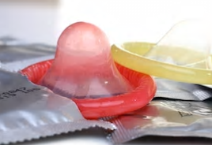 | Female condom  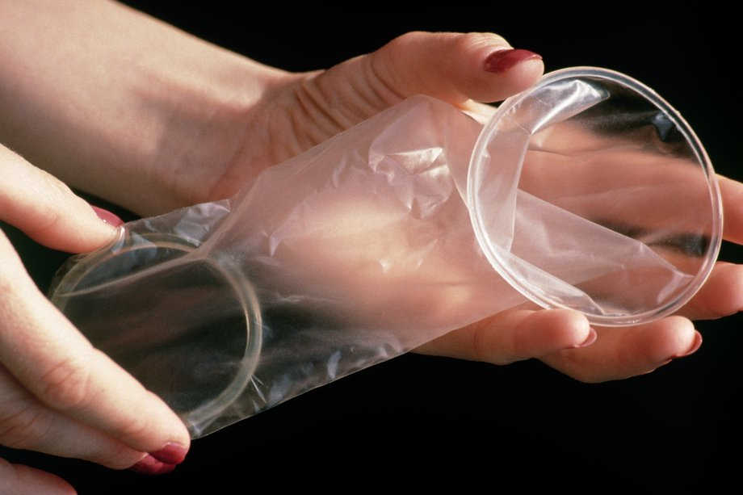 | Diaphragm (Caya™)  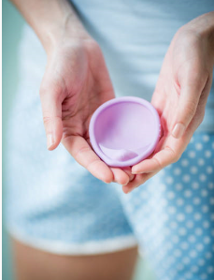

Emergency contraception

Emergency contraception can be used after unprotected sex to reduce the chance of becoming pregnant.
- The copper IUD is the most effective method of emergency contraception when inserted within five days of unprotected sex. It can then provide effective contraception for at least five and up to 10 years.

- The emergency contraceptive pill should be taken as soon as possible after unprotected sex for maximum effectiveness, but it is not 100 per cent effective in preventing pregnancy. The earlier it is taken the better but can be taken up to three or five days after unprotected sex.
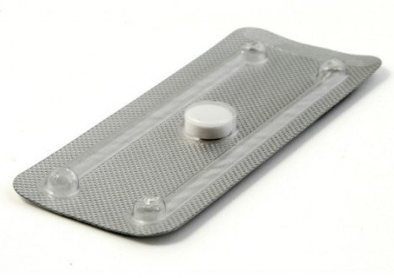

Natural methods of contraception

Natural methods of contraception include the withdrawal and natural fertility methods. Both require the motivation, awareness and cooperation of both partners. They are the least effective methods of contraception.
- Women using natural fertility awareness methods observe certain bodily signs every day to determine when they are fertile. During that time, they avoid sex or use contraception (for up to 16 days per menstrual cycle).
- ‘Withdrawal’ requires a man to withdraw his penis during intercourse before ejaculation. However, as sperm is present before ejaculation, pregnancy may still occur.

Permanent methods of contraception

Sterilisation is a permanent method of very effective contraception that involves having a surgical procedure.
- Female sterilisation is called tubal ligation (or ‘having your tubes tied’). It involves minor surgery under general anaesthetic where a clip is put on each fallopian tube to prevent the sperm and egg from meeting.
- Male sterilisation is called vasectomy. It involves surgery (under local or general anaesthetic) to cut the tubes that carry sperm from the testes to the penis.

Where to get help
- 1800 my options Tel. 1800 696 784 Interpreter 131450
- Your GP
- Refugee health http://refugeehealthnetwork.org.au/refer/refugee-health-nurse-program/
- Pharmacy
- Community health service: https://www2.health.vic.gov.au/primary-and-community-health/community-health/community-health-directory
- Family Planning Victoria Tel. 1800 013 952 or (03) 9257 0100

Authorised and published by the Victorian Government, 1 Treasury Place, Melbourne.
© State of Victoria, Department of Health and Human Services, January 2019.
Available at <http://healthtranslations.vic.gov.au/>

